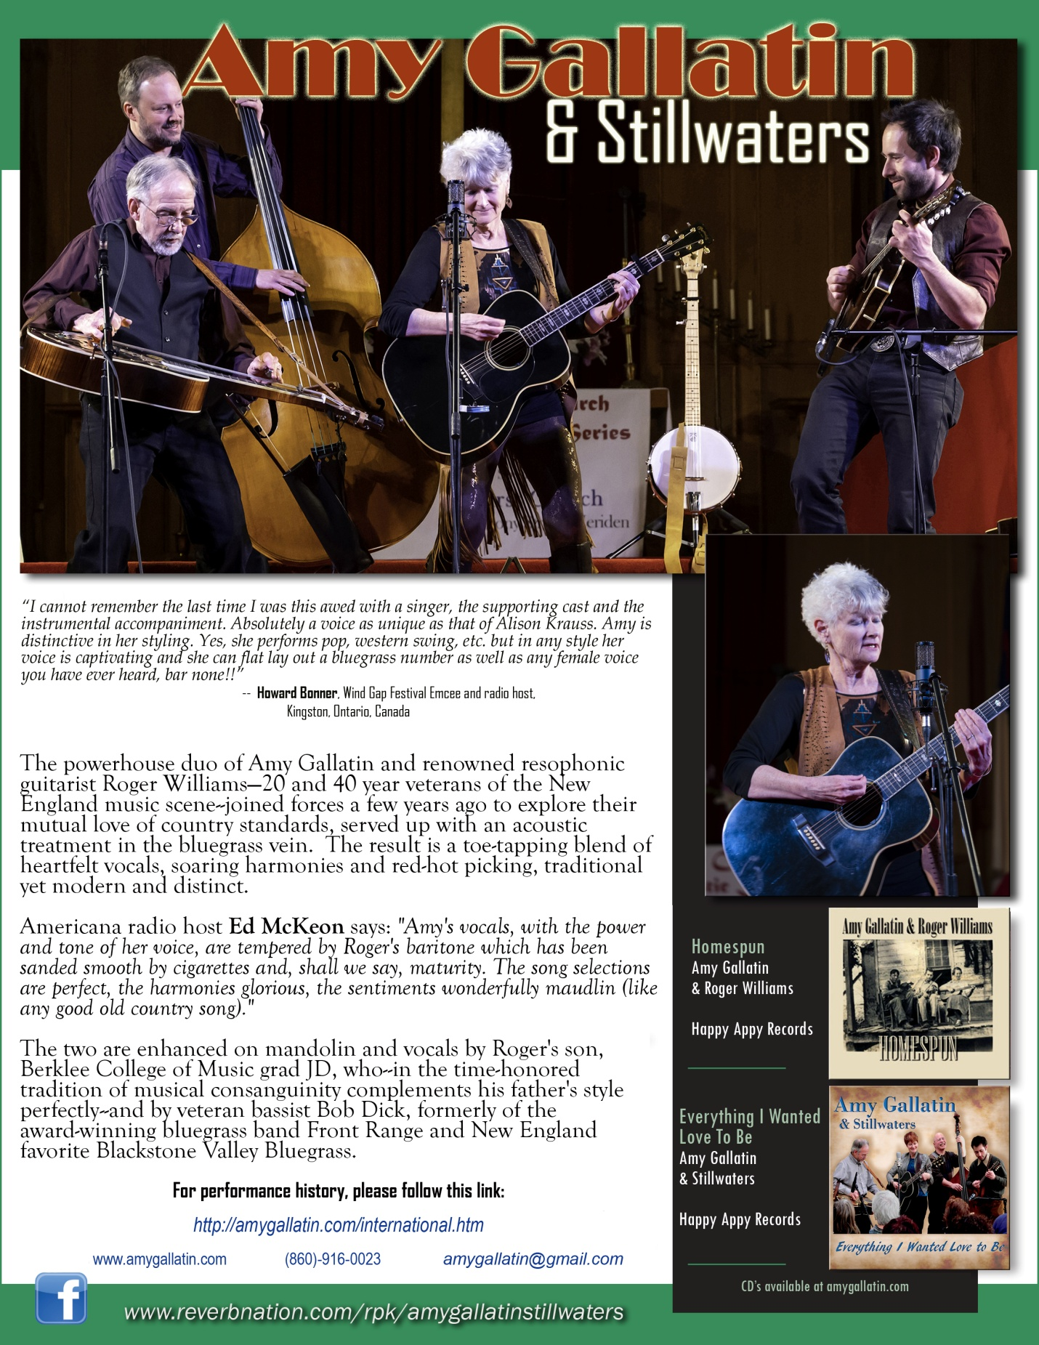

*The powerhouse duo of Amy Gallatin and renowned resophonic guitarist Roger Williams—20 and 40 year veterans of the New England music scene--joined forces a few years ago to explore their mutual love of country standards, served up with an acoustic treatment in the bluegrass vein. The result is a toe-tapping blend of heartfelt vocals, soaring harmonies and red-hot picking, traditional yet modern and distinct.*

Americana radio host Ed McKeon says: *"Amy's vocals, with the power and tone of her voice, are tempered by Roger's baritone which has been sanded smooth by cigarettes and, shall we say, maturity. The song selections are perfect, the harmonies glorious, the sentiments wonderfully maudlin (like any good old country song)."*

The two are enhanced on mandolin and vocals by Roger's son, Berklee College of Music grad JD Williams, who--in the time-honored tradition of musical consanguinity complements his father's style perfectly--and by veteran bassist Bob Dick, formerly of the award-winning bluegrass band Front Range and New England favorite Blackstone Valley Bluegrass.

-----------------------------------------------------------------------------------------

For performance history, please follow this link:

<http://amygallatin.com/international.htm>